4.43:

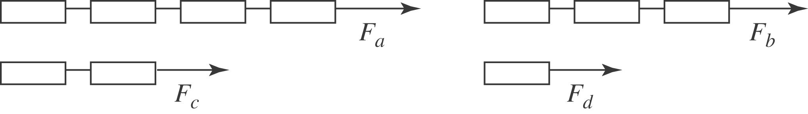

a) The engine is pulling four cars, and so the force that the engine exerts on the first car is 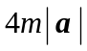. b), c), d): Similarly, the forces the cars exert on the car behind are 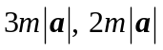 and 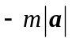. e) The direction of the acceleration, and hence the direction of the forces, would change but the magnitudes would not; the answers are the same.

